Law Firm Case Management

Overview:
The Law Firm Case Management System is a SharePoint-based application designed to help legal professionals manage cases, clients, tasks, hearings, and documents efficiently. It provides a centralized platform for tracking case progress, scheduling hearings, assigning
tasks, and storing related documents.

Key Features:
  - Module-Based Navigation: Easily access and manage different modules such as Cases, Clients, Tasks, Hearings, Documents, Calendar, and Payments through a structured tab-based interface for seamless workflow.
  - Case Management: Create, edit, and track legal cases with detailed metadata.
  - Client Management: Store and manage client information.
  - Task Tracking: Assign and monitor case-related tasks.
  - Hearing Scheduling: Schedule and manage court hearings.
  - Document Management: Upload and organize case-related documents.
  - Case Calendar: View all hearings, tasks, deadlines, and overdue activities in a centralized calendar for better scheduling and planning.
  - Payment Management: Track client payments, view total received and pending amounts, monitor transaction history, and check last payment details for each client.
  - Advanced Filtering: Filter cases by type, status, progress, and dates.
  - Trial Limit Management: Free version with a 5-case limit (upgrade for more).

Deployment Steps:
- Package the Solution (SPPKG)
  - Build the SPFx solution: gulp bundle --ship
gulp package-solution --ship
  - Locate the .sppkg file in the sharepoint/solution folder.

Deploy to SharePoint App Catalog
  - Upload the .sppkg file to the SharePoint Tenant App Catalog.
  - Click Deploy to make it available across sites.

Add the Web Part to a SharePoint Page
  - Edit a SharePoint page.
  - Click + Add a web part and select the Law Firm Case Management web part.
    - Configure the web part properties if needed.

Step-By-Step Functionality Guide:
- Initial Setup (One-Time Configuration)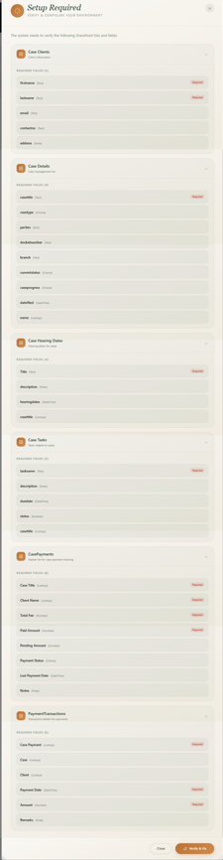

  - The system will automatically check for required SharePoint lists.
  - If lists are missing, a setup wizard will guide you through creating them.
  - You just need to click on the Verify & Fix button.

Case Management:

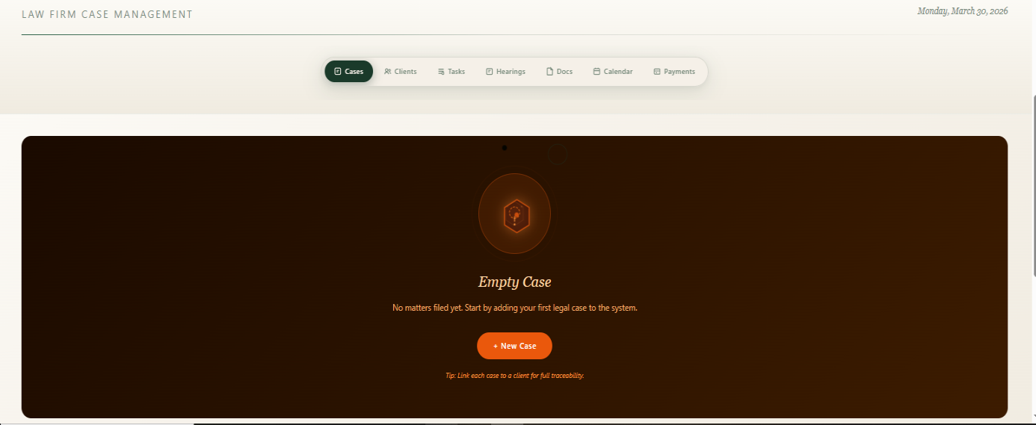

  - This is an Empty Case UI (When User does not have any case).
  - After clicking on the Add Case button you will see the next page output.

Adding a New Case:

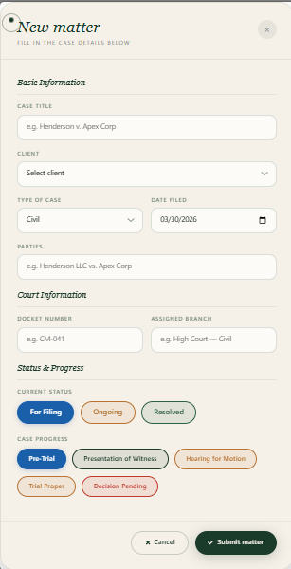
  - When User click on Add Case button this form will open, and the user have to fill out all the required details of form and after clicking on submit button user can see following output.

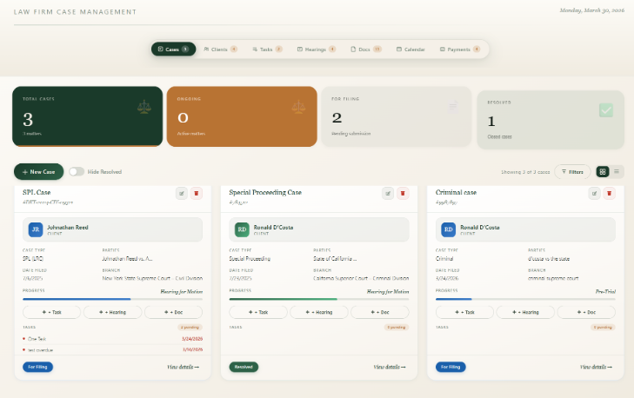

  - The Case Management System is a sophisticated legal workflow
management platform designed to enhance efficiency, organization, and compliance for law firms, corporate legal teams, and judicial administrators. Below is a structured breakdown tailored for client
presentations or stakeholder reviews.
  - The system centralizes case tracking, document management, hearing
schedules, and task delegation into a single, intuitive interface—reducing administrative overhead and minimizing human error.
  - To Edit the case user needs to click on the Edit icon button available in the case card which will open the from in edit modal, modify the details and click on update button to save the details.
  - To delete the case, user needs to click on the Delete icon button available in the case card which will open a confirmation pop up, click on delete to delete the case card.
  - User can click on the case card that action will open the case details modal which contains all case information.

Clients:

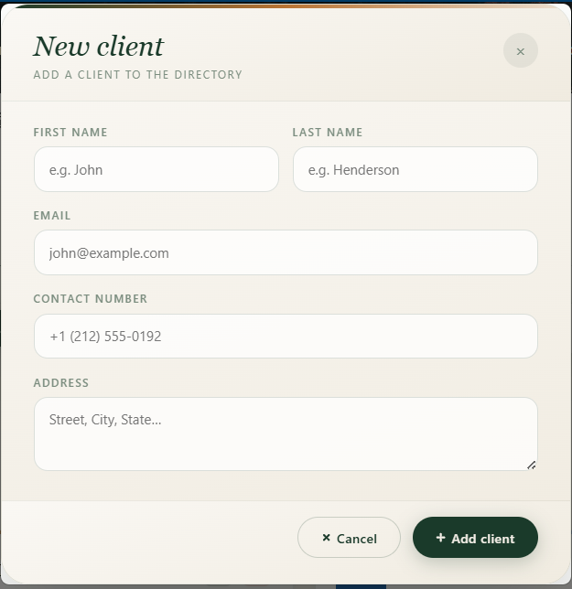
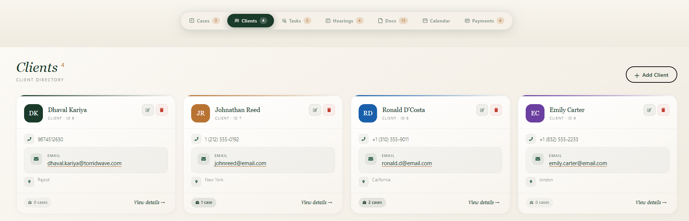

  - The Clients UI describes information of clients related to the case, User can view All Client’s Details in this view.
  - To Edit the Client, user needs to click on the Edit icon button available in the Screen which will open the from in edit modal, modify the details and click on update button to save the details.
  - To delete the Client, user needs to click on the Delete icon button available in the Screen which will open a confirmation pop up, click on delete to delete the Client.
  - The Clients can directly be viewed in the Clients Dropdown available in the Add Case Form.

Hearing Dates:

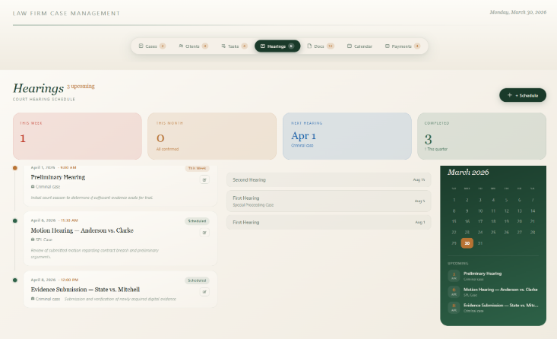

  - This Image describes the Hearing Dates of the particular case which can be added by user.
  - To Edit the Hearing Dates, user needs to click on the Edit icon button available in the card which will open the from in edit modal, modify the details and click on update button to save the details.
  - To delete the Hearing Dates, user needs to click on the Delete icon button available in the case card which will open a confirmation pop up, click on delete to delete the Hearing Date.

Documents:

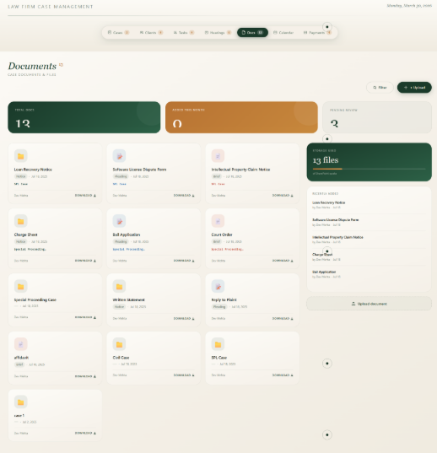

  - This describes information of Documents which are submitted for the particular Case.
  - User can click on the View button to Download the particular Document.
  - To delete the Document, user needs to click on the Delete icon button available in the card which will open a confirmation pop up, click on delete to delete the Document.

Tasks:

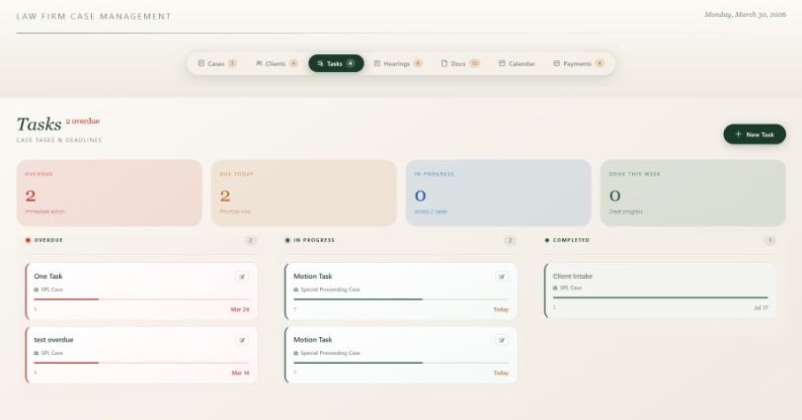

  - After clicking on the name of the Task (Available in the case card main screen), User can View the Tasks related to Case.
  - To Edit the Task, user needs to click on the Edit icon button available in the Task card which will open the from in edit modal, modify the details and click on update button to save the details.

  - To Delete the Task, user needs to click on the Delete icon button available in the Task card which will open the confirmation pop up, after clicking on the delete user can delete the Task.

- Case Calendar:

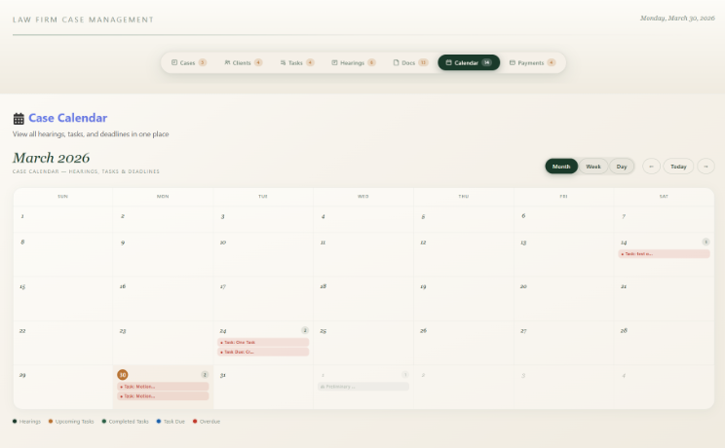

  - All hearing dates, deadlines, and case-related events are organized in a single calendar view, making it easy for users to manage and track case activities efficiently.
  - Users can quickly identify upcoming hearings, overdue tasks, and completed events, helping them stay updated and avoid missing critical legal deadlines.
  - The calendar enables better planning by providing a clear timeline of case activities, allowing legal professionals to prioritize tasks and manage workload effectively.

- Case Payments:

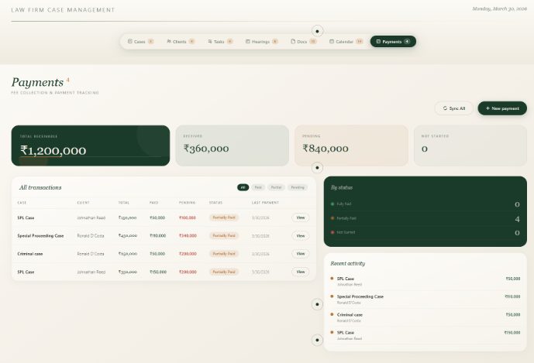

  - The system provides a detailed audit of payments made by each client, including the total amount received, pending balances, and a complete transaction history for better financial visibility.

- Users can easily monitor individual client payment status, including outstanding dues and last payment date, enabling quick follow-ups and improved client management.

- The dashboard displays total revenue received and overall pending amounts across all clients, helping legal professionals analyze cash flow and make informed financial decisions.

